Trophy Sponsor

Sheet
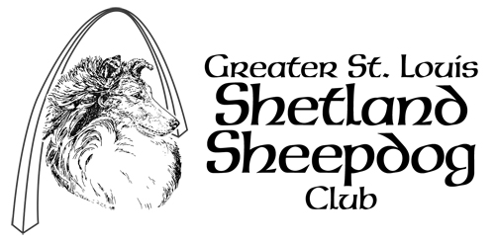

Conformation Classes

NOTE: Trophy’s listed below are only suggestions – depending on the show and classes offered, and available funds it may be necessary to delete some of the offerings below and/or add or substitute others
Trophy Being Sponsored | Sponsored By | Amount Pledged | Notes
Best of Breed

Best of Opposite Sex

Best of Winners

Winners Dog

Winners Bitch

Reserve Winners - Dog
Reserve Winners -Bitch
First Place - Dogs
6-9 Month Puppy
First Place - Dogs
9-12 Month Puppy
First Place - Dogs
12-18 Month Puppy
First Place – Dogs
Bred By Exhibitor
First Place – Dogs
American Bred
First Place – Dogs
Open Sable
First Place – Dogs
Open AOC
First Place - Bitches
6-9 Month Puppy

First Place - Bitches
9-12 Month Puppy
First Place - Bitches
12-18 Month Puppy
First Place – Bitches
Bred By Exhibitor
First Place – Bitches
American Bred
First Place – Bitches
Open Sable
First Place – Bitches
Open AOC

