Trophy Sponsor

Sheet
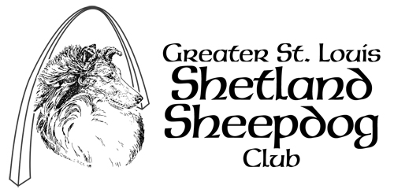

Obedience Classes

NOTE: Trophy’s listed below are only suggestions – depending on the show and classes offered, and available funds it may be necessary to delete some of the offerings below and/or add or substitute others.
Trophy Being Sponsored | Sponsored By | Amount Pledged | Notes
High In Trial

High Combined

First Place
Novice A
First Place
Novice B
First Place
Open A
First Place
Open B
First Place
Utility A
First Place
Utility B
First Place
Veterans
First Place
Pre Novice
First Place
Graduate Novice
First Place
Graduate Open
First Place
Wild Card – Novice
First Place
Wild Card - Open
First Place
Wild Card - Utility

