Trophy Sponsor

Sheet
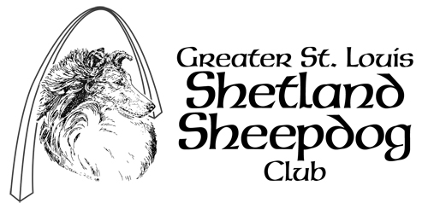

Rally Obedience Classes

NOTE: Trophy’s listed below are only suggestions – depending on the show and classes offered, and available funds it may be necessary to delete some of the offerings below and/or add or substitute others.
Trophy Being Sponsored | Sponsored By | Amount Pledged | Notes
High In Trial

High Combined

First Place
Novice A
First Place
Novice B
First Place
Advanced A
First Place
Advanced B
First Place
Excellent A
First Place
Excellent B

